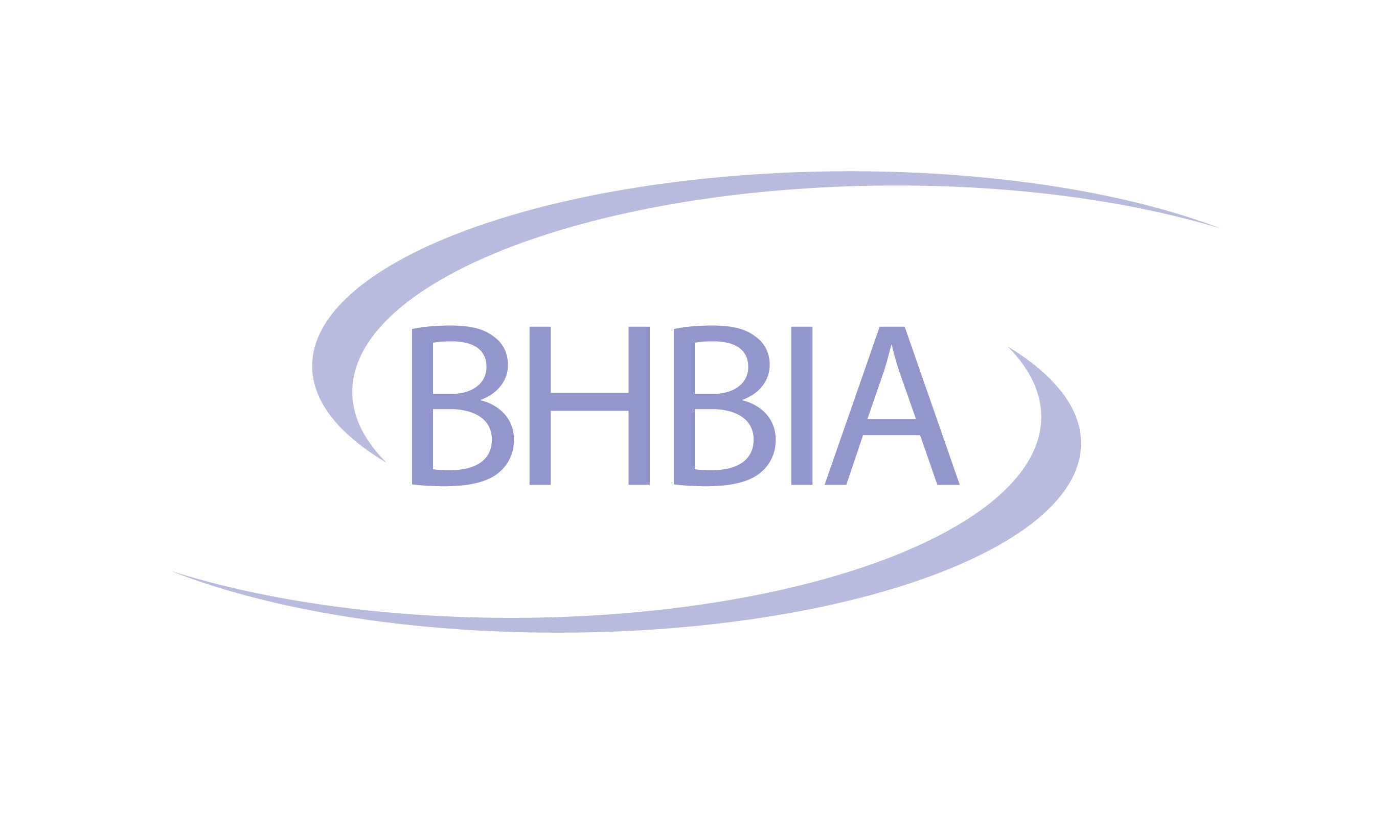

Legal & Ethical Guidelines Training Workshop

The BHBIA’s one day ‘Legal & Ethical Guidelines’ Workshop is designed to help you:

* Better understand the scope, purpose and key principles of the Guidelines
* By working through practical examples based on real life scenarios better understand the BHBIA’s legal and ethical guidelines with regard to:
  + Respondents’ rights
  + Researchers’ responsibilities
  + Protecting data integrity
* Be better equipped to navigate the Guidelines

|  |  |  |  |  |  |  |
| --- | --- | --- | --- | --- | --- | --- |
| Delegate Resume | | | | | | |
| Name | |  | | | | |
| Company | |  | | | | |
| Position | |  | | | | |
| No. Years at your current company |  | | No. Years in Healthcare MR |  | No Years in MR |  |
| MR Expertise  *Brief summary of your specialist area(s) of expertise, if appropriate* | |  | | | | |

|  |  |
| --- | --- |
| Personal Training Goals *If any, in addition to the course goals – see previous page* |  |
| Your ethics’ issues  *Could include areas or issues of particular interest, concern or confusion*  *Feel free to include any relevant experiences or examples*  *Include any questions you want to see addressed* |  |

Thank you for your help